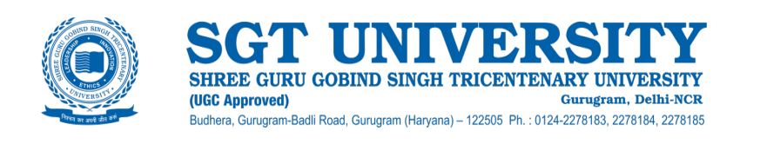

**2.5.4 Positive impact of reforms on the examination procedures and processes including IT integration and continuous internal assessment of the examination management system.**

Examinations are the most important part of academic activities, keeping this thought in mind SGT University has designed the whole Examination process very carefully. The following measures have been taken during the last five years in our examination system:

**Continuous assessment:**

For all programs, the class and mid-term tests are also conducted on the pattern of end-term examination by the respective departments. The evaluated sheets are shown to students for their satisfaction. Further, students are assessed using quizzes, case studies, student seminars, group discussions, etc.

**Setting of question papers:**

Question papers are designed as per the bloom taxonomy. A moderator for each question paper is appointed for the course and program outcome mapping and moderation. Each question paper scrutinized for errors and rectification well beforehand.

**Online Examination Platform:**

In the outbreak of the COVID-19 pandemic, SGTU conducted proctored Online Examinations with the sanctity of academic expectations and integrity of the examination process in a shorter period of time in compliance with CBCS requirements as prescribed by UGC. The university conducted the practical examinations and Viva-Voce Examinations through WebEx and MS Team for intermediate semesters.

**Ph.D. submission and evaluation:**

Ph.D. thesis are evaluated by two external examiners selected by the Vice-Chancellor from the panel recommended by the concerned BOS, one of whom should be from outside the state. The thesis are deposited on “Shodhganga” by the Central Library of the University.

**Security features in Degrees/DMCs:**

Degrees are got printed on tearless paper with the following new security features introduced in the Degrees/DMCs of the SGT university:

* Copy Void Features
* Security Design
* Micro-line
* Transparent Printing
* Sr. No. Printing
* Invisible Printing
* Florescent Colour
* Non-Copy-able Security
* Border Non-tear-able paper (PTM 350 GSM)
* QR Code
* Barcode
* Printed Water Mark

**DMCs and Degrees Uploaded on NAD portal:**

SGT University has a NAD Cell. All the DMCs and final Degrees are now being uploaded on the NAD portal. So far, approximately - 6000 documents have been uploaded on the said portal.

**Technology Adoption:**

Department of Examinations is completely covered by the best Audio and Video CCTV cameras. CCTV cameras also have been fitted in the examination halls of the SGTU where most of the examinations are conducted during the year.

**Automation in Examination:** The department of Examinations is completely automated in terms of

* Examination Form Open/Close
* Student Exam Form Filling Through Student Login
* Examination Form Summary
* Hall Allotment
* Attendance Sheet
* Create Timetable
* Examination Form Approval
* Date Sheet Generation
* Admit Card
* Student Marks Filled with Secrecy code
* Result Processing

**OSCE and OSPE:**

OSCE and OSPE have been introduced in several departments of medical and dental sciences. OSCE is being used for formative assessment in several departments. The SGTU also encourages use of OSCE in the assessment of other allied medical health departments.

**Competency – based assessment**:

Competency – based assessment is used in medical, technical and professional programmes in terms of Seminars, Quizzes, industrial exposure, case study, field training and Moot court.

**Workplace-based assessment:**

Workplace-based assessment is followed in Medical, Dental, Nursing, Hotel Management and in Engineering faculty of studies of SGTU.